**Suggested Reading:** Bunker (Chapter 3) [3], “Total Electron-Yield (TEY) Detector for X-Ray Absorption Spectroscopy in Fluorescence Mode” [2], “An Experimental Comparison of the Total-Electron-Yield and Conversion-Electron-Yield Modes for near-Surface Characterization Using X-Ray Excitation” [5]

**Vocabulary Words:**

**Yield:** The total amount or quantity produced. In total electron yield mode, every electron which escapes the material is considered in the signal.

**Auger Effect:** When a core hole left behind by an absorption event is filled, the atom goes from a higher energy to a lower energy state. Often we think of this energy difference as being released in the form of a fluorescence photon, but it can also manifest as the emission of a second electron known as an Auger electron via the Auger effect.

**Cascade:** When an electron is released in a material it often scatters off of nearby atoms. If the initial electron has sufficient energy, other electrons can be freed with each scattering event. This turns one high energy electron into multiple lower energy electrons known as an electron cascade.

**Exercise:**  There are roughly 60 X-ray and vacuum ultraviolet (VUV) light sources all over the world. Below is a diagram for the ones contained in Europe and the Middle East. Fill the bubbles with the numbers that correspond to the light source located in each area.

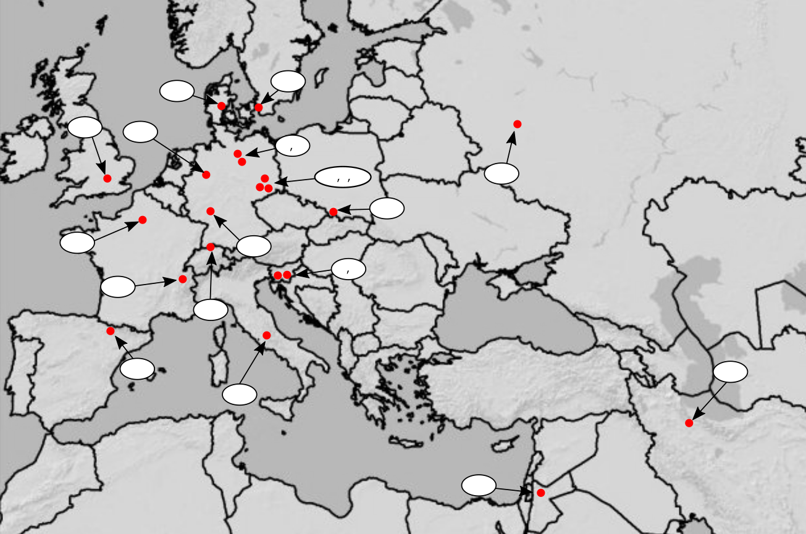

1. Diamond Light Source
2. SOLEIL
3. ALBA
4. European Synchrotron  
   Radiation Facility( ESRF)
5. Swiss Light Source (SLS)
6. Angströmquelle Karlsruhe (ANKA)
7. Dortmund Electron Storage Ring  
   Facility (DELTA)
8. Institute for Storage Ring Facilities  
   (ISA)
9. MAX IV
10. Deutsches Elektronen-Synchrotron   
    (DESY)
11. European X-ray free-electron laser  
    (XFEL)
12. Helmholtz Zentrum Berlin (HZB)
13. Metrology Light Source (MLS)
14. Free-electron laser at the   
    Electron Linear accelerator with high  
    Brilliance and low Emittance (FELBE)
15. SOLARIS
16. Elettra
17. Free Electron laser Radiation for  
    Multidisciplinary Investigations  
    (FERMI)
18. DAFNE-Light
19. Iranian Light Source Facility
20. Synchrotron-Light for Experimental Science and Applications in the Middle East (SESAME)
21. Kurchatov Synchrotron Radiation Source (KSRS)
22. Introduction:

Total electron yield mode is similar to fluorescence mode in that it relies on the detection of particles produced as a result of the absorption process to infer the absorption coefficient 𝜇, instead of measuring it directly as is done in transmission mode.

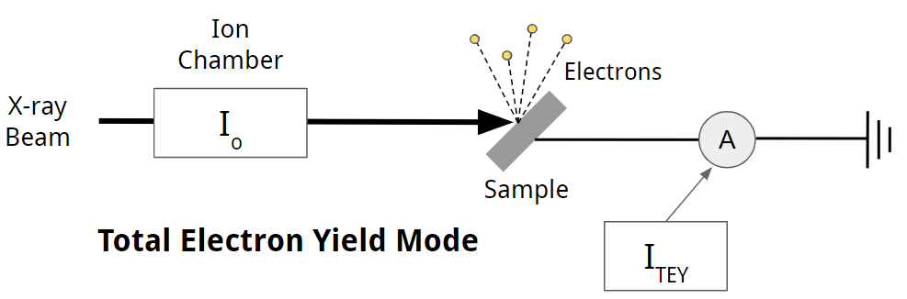

* 1. Based on the (simplified) diagram below, what are the two processes by which the excited atom can relax? In general terms, what is the difference in these two processes? In which types of atoms are they more likely to occur?

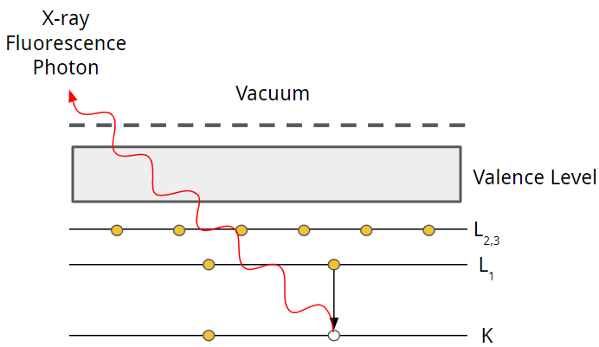

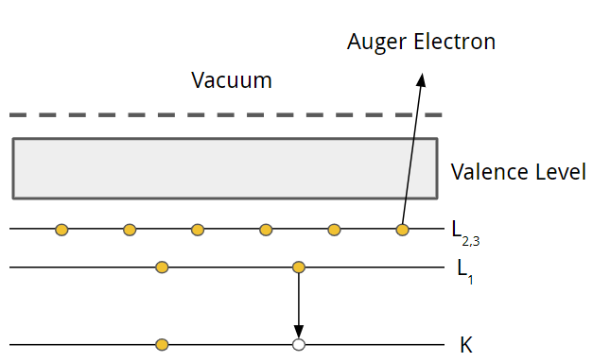

They can relax either by emitting a fluorescence photon or an Auger Electron. Note that real systems may follow a more complex relaxation path depending on multiple factors, most notably the atomic number Z, where a combination of fluorescence photons and Auger electrons are emitted. The Auger process is non-radiative while the fluorescence photon is. Auger electrons are the dominant relaxation process in low Z atoms while fluorescence dominates in high(er) Z atoms. They have approximately equal probability of occurring at around Z=32.

* 1. Two possible relaxation processes to fill the 1s hole for Cu in a model XAFS study are shown in the figure of the previous problem – one a fluorescence process and the other an Auger relaxation. Given a rough estimate for the escape length of Cu Ka fluorescence from pure Cu (see ref [4]). What about the escape length for the 2p Auger electron?

Auger electrons typically have an escape length on the order of a few nanometers at best, while the fluorescence photons tend to have much longer escape lengths. The Cu Ka fluorescence is at 8 keV which corresponds to an attenuation length (escape length) of approximately 10 to 20 microns.

* 1. How do these differences lead in escape lengths (above) to different sensitivity in XAFS based on fluorescence instead of XAFS based on detecting electrons that escape the sample? What part of the material is TEY mode most sensitive to? Explain.

It becomes highly surface sensitive. This is due to the small inelastic mean free path of electrons in any reasonably dense material. If an electron is created with sufficient energy to overcome the work function, it still may have lost too much energy through inelastic scattering or plasmon excitations by the time it actually reaches the surface. This is why photoelectrons created very near the surface have a much higher chance of escaping the material and being detected, making TEY highly surface sensitive.

* 1. Based on the highly simplified diagram below, explain why the total photoelectron yield can still be used to measure the absorption coefficient.

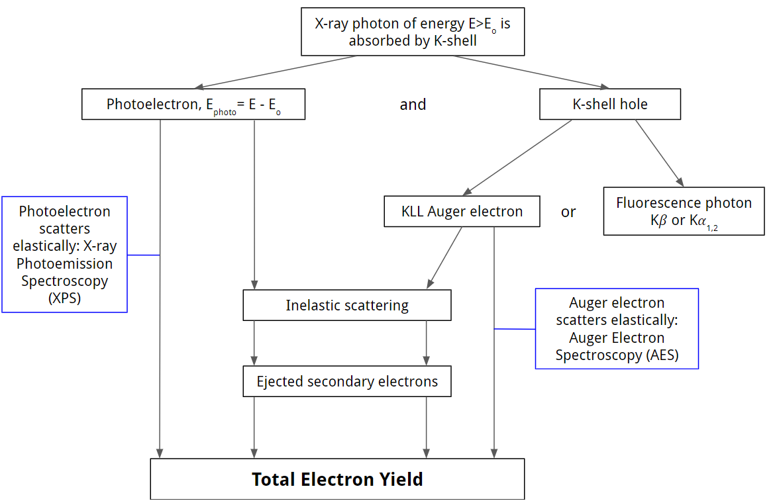

1. Total Electron Yield
   1. What are some examples of when TEY mode might be used? Feel free to look at ref [1] to read about one of the first applications of the technique.

The Total Electron Yield mode is useful in the soft x-ray regime (500 eV to 2 keV) where the absorption length is very short. In this energy range, samples must be incredibly thin for transmission mode, making it difficult to manufacture samples that do not exhibit a distinct pinhole effect. If the sample is thick/concentrated and cannot be made dilute, then fluorescence mode is often not viable. For these thick/concentrated samples or when surface sensitivity is desired, TEY is the best choice.

* 1. Given what you know about the sensitivity of TEY mode, why is the self-absorption issue of fluorescence mode not a concern for TEY mode?

The active region which TEY is able to sample is relatively small. Self-absorption issues come from having the attenuation length comparable to the thickness of the sample.

* 1. What is one of the largest limitations on the samples used in TEY mode?

The sample must be electrically conductive or at least be able to be modified so that electrons lost from the Auger and photoemission process can be replaced. The sample has to be connected to a cathode. Because it is constantly losing electrons, it must be able to replenish them quickly enough to maintain a measurable signal.

* 1. One common method for measuring the TEY mod signal is to connect the sample to an electric ground. The drain current is then measured as the sample is irradiated, as shown in the figure below. Explain how one could use this drain current to effectively measure the fine structure.



Most materials want to be electrically neutral, so if a material loses electrons through photoemission, it will seek to replace them (especially if it is conductive) by taking electrons from the environment. The drain current is effectively a measurement of how many electrons the sample is losing when it is irradiated with x-rays of a particular energy. When the energy of the incident x-rays matches that of an edge in an element of interest, we should expect there to be a jump in the number of electrons being lost (just as we would expect to see with absorption) and therefore a jump in the drain current. By measuring how the drain current changes in the vicinity of an absorption edge, we can effectively measure the fine structure of that edge.

* 1. It is common for total electron yield mode and fluorescence mode to be done simultaneously on a sample. What advantage does this have when it comes to the post processing of the fluorescence mode data?

TEY mode does not have the issue of self absorbance, which means that it can be used as a rough benchmark to compare the fluorescence mode data against. While the data from TEY mode may be noisy, it can generally be useful for confirming that the self-absorption correction is actually accurate.

1. Conversion Electron Yield and Partial Electron Yield
2. Below is a diagram of a conversion electron yield experimental setup, which works in a method similar to a gas ionization chamber. What advantages does CEY mode provide over conventional TEY mode?

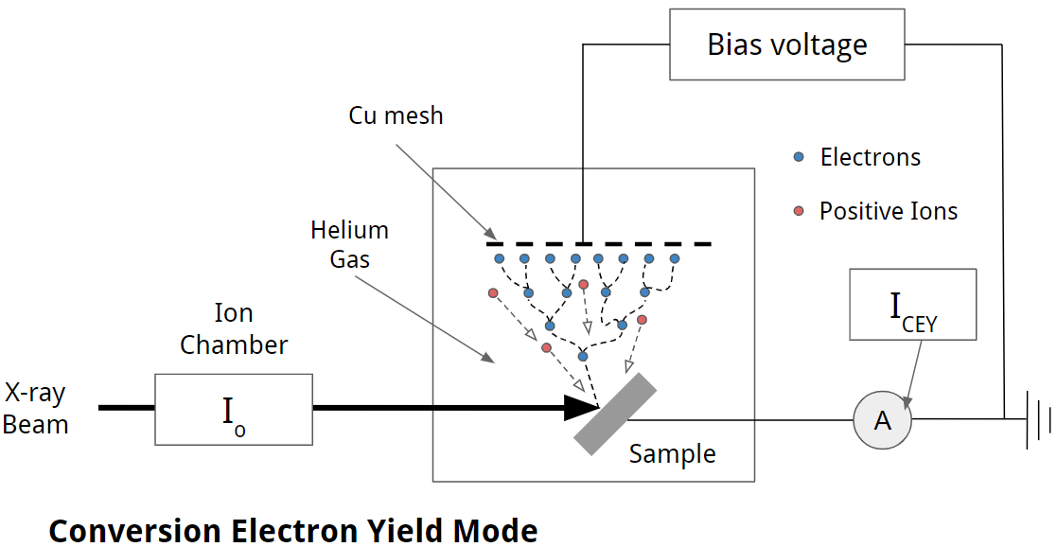

CEY mode does not require the experiment to take place in vacuum, and allows the sample to be probed in an atmospheric environment. Also the signal intensity in CEY mode is higher than that of TEY mode because the ionization of the helium molecules forms multiple ion-electron pairs in the gas.

1. What role does the bias voltage play in the above diagram?

Generally the bias voltage helps electrons escape from the surface, helps the electrode draw in the free electrons, and prevents the ion-electron pairs of the Helium gas from recombining.

1. See the paper listed in ref [5]. What are the key differences between conventional TEY mode and CEY mode? Which of the two was found to have a deeper probing depth? Explain.

TEY signal relies entirely upon the number of electrons emitted from the sample. CEY on the other hand depends upon the kinetic energy of the electron being emitted from the sample, as the greater the kinetic energy the greater the avalanche effect and the larger signal which is detected. Put another way, the CEY signal is dominated by contributions from high-energy electrons which are able to ionize more gas molecules, forming more ion-electron pairs. CEY has a deeper probing depth.

1. Consider the relationship between the electron path length in the material and the final energy the electron has when it leaves the material. On average, the longer the path length, the more energy the electron loses before it escapes the surface of the material. In general terms, how could this be used to study depth dependent x-ray absorption?

By limiting the energy range of the electrons that are being counted, one can limit the depth range that they are sensitive to. This is exploited in PEY mode and requires that the energies of the detected electrons be discriminated in some way.

Citations:

[1] Zheng, Lei, et al. “Total Electron Yield Mode for XANES Measurements in the Energy Region of 2.1–6.0 KeV.” *Chinese Physics C*, vol. 35, no. 2, 2011, pp. 199–202., doi:10.1088/1674-1137/35/2/018.

[2] Poswal, Ashwini Kumar, et al. “Total Electron-Yield (TEY) Detector for X-Ray Absorption Spectroscopy in Fluorescence Mode.” *Dae Solid State Physics Symposium 2019*, 2020, doi:10.1063/5.0016961.

[3] Bunker, Grant. *Introduction to XAFS: a Practical Guide to X-Ray Absorption Fine Structure Spectroscopy*. Cambridge University Press, 2010

[4] *X-Ray Attenuation Length*, henke.lbl.gov/optical_constants/atten2.html. B.L. Henke, E.M. Gullikson, and J.C. Davis. X-ray interactions: photoabsorption, scattering, transmission, and reflection at E=50-30000 eV, Z=1-92, Atomic Data and Nuclear Data Tables Vol. 54 (no.2), 181-342 (July 1993)

[5] Zheng, S., et al. “An Experimental Comparison of the Total-Electron-Yield and Conversion-Electron-Yield Modes for near-Surface Characterization Using X-Ray Excitation.” *Journal of Electron Spectroscopy and Related Phenomena*, vol. 87, no. 1, 1997, pp. 81–89., doi:10.1016/s0368-2048(97)00081-9.